Pitching - how to present a project to an investor?
Topic:
The workshop is aimed at everyone who wants to know how to effectively present business projects in front of investors. Participants will gain knowledge on how to prepare a professional pitch deck and will have the opportunity to put this knowledge into practice by making a trial presentation. The trainer bases on many years of experience in supporting and supervising the development of the PPNT Seed Fund portfolio companies, long-term cooperation with originators, investors, as well as small, medium and large companies.
Date:
25 August 2021 10 a.m. - 3 p.m.
Agenda:
Time: | Agenda:
10:00 – 11:30 | - Introduction to the workshop  - What are investors looking for and who are they investing in?
 | 10-minute break
11:40 – 12:30 | - How to present business to an investor?  - Pitch deck - what should a presentation contain?
 | 10-minute break
12:40 – 13:30 | - Preparation of individual pitch deck
 | 30-minute break
14:00 – 15:00 | - Pitching simulation  - Workshop summary

About the trainer:
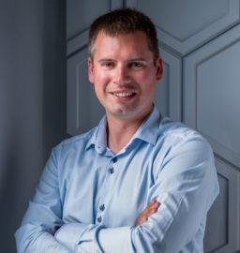
Piotr Nędzewicz - Head of Commercialisation and Business Development, Coordinator of DIH4Future.
He is responsible for implementation of projects related to commercialisation of new technologies, digital transformation and innovative business development. He started his career in 2007 in one of the international auditing and consulting companies. He has been working for Poznan Science and Technology Park (PPNT) since 2011. Initially, as a technology transfer consultant and innovation specialist, he supported companies in developing business based on new technologies. Between 2016 and 2017, as an investment manager of the PPNT Seed Fund and a member of the supervisory boards of portfolio companies, he was responsible for investments in new technological ventures. Since 2018, he has been managing the Commercialisation and Business Development Department. From 2020 he is responsible for the development of the Digital Innovation Hub DIH4Future. He is an expert of the European Commission (EIC Accelerator Evaluator Expert) and a member of the Wielkopolska Regional Council of the Future Industry.
Registration:
For registration, please, send the following information about Your company (in English):
- the company name
- contact e-mail address and the company's website, if possible
- a brief description of the company's activities,

to the e-mail address: agata_karcz@parp.gov.pl
Registration will last until 20 August 2021 12:00 a.m. or until the completion of a group of participants.

